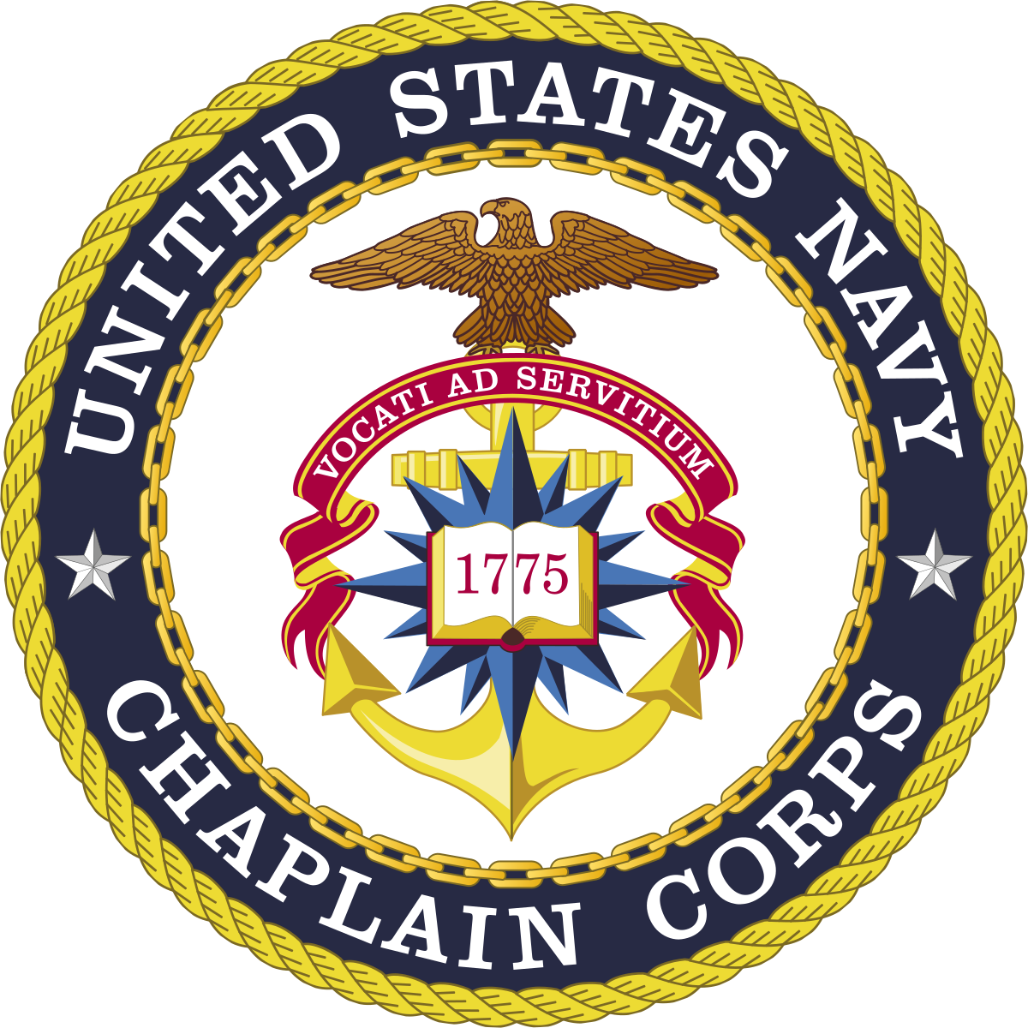

**Marine Corps Security Force Regimental Chaplain**

**2122 Longfellow Rd**

**Naval Weapon Station Yorktown**

**Yorktown, VA 23691-5119**

**Room 128A**

**Religious Program Specialist Office (757) 637-9369**

**Chaplain Office (757) 637-9382**

**Chaplain Cell (Emergencies only) (757) 618-1752**

**US Navy chaplains are non-combatant naval officers who serve the Navy, Marine Corps, and Coast Guard. They deploy with the troops aboard ships and on the ground, wear the uniform of the branch they serve, and eat the same food as the troops. They are ordained members of the clergy who represent their individual denominations as well as serving all who placed under their spiritual care.**

**Chaplains have 100% confidentiality. This is called Privileged Communication and means that anything a service member tells them is not reported. This ensures the service member has a trained professional with whom they can speak without fear of reprisal. They offer counselling for a wide variety of issues such as spiritual enrichment, marriage/pre-marriage, individual growth, PTSD, anger, and grief. Chaplains are also available to help service members’ dependents.**

**Navy Chaplains operate under the auspices of four core capabilities. They are:**

1. **Care for all with counselling and conversation**
2. **Facilitate worship for people of all faith groups. (Chaplains do not conduct services outside of their own belief system but will strive to ensure the free practice of religion for all.)**
3. **Provide Worship for their own faith groups.**
4. **Advise their commanders on issues pertaining to religion, morals, ethics, and troop well-fare**

**Do Not Hesitate to Contact the Chaplain with Your Questions and Concerns!**